**Lab report**

15

Digital Communications - Experiment DKL-4

***Channel coding, modulation, demodulation, decoding***

**Author- Sobbosachi Mojumder**

S Berk Çemberci

Sukrat khanna

Vusi  Mohlabine

# Channel coding, modulation, demodulation, decoding

In this experiment we used a transmitter side coding box and a receiver decoder box. Its input is an 8-bit data word which comes directly from an A/D converter. The voltage can also be adjusted using a potentiometer, so that we can get all data words between 0 and 255 with it. The output is a D/A converted analogue output of the decoded data word, using error correction in between.

The error correction uses cyclic codes which internally do polynomial divisions in GF (2) by shift registers and XOR gates. Only certain polynoms give a valid code.

1. Connect the sender and receiver coding and decoding box and verify that you have the same value at the output which you’ve at the input.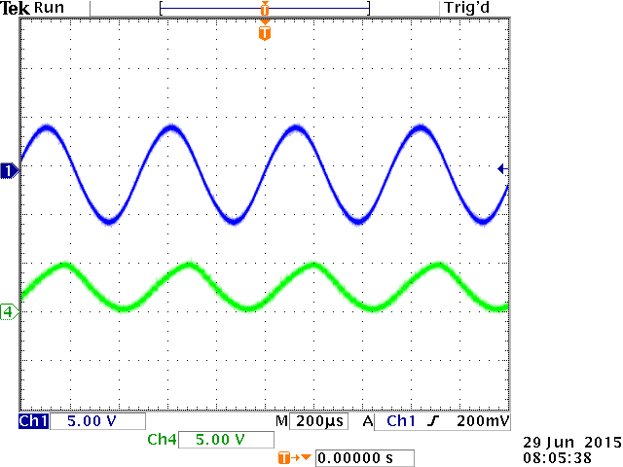
2. An audio source to the A/D converter has been supplied and listened to the output signal using the loudspeakers.

1. If one error to the code (7bit ) word added it will not be anymore sine wave. As shown below.

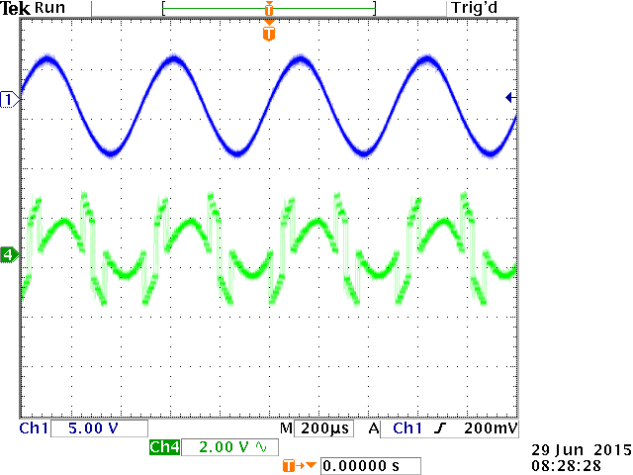

1. If a random bit error generator is applied then in then it will not be a sine wave.
2. If two errors to each code word added then there will be only a line.

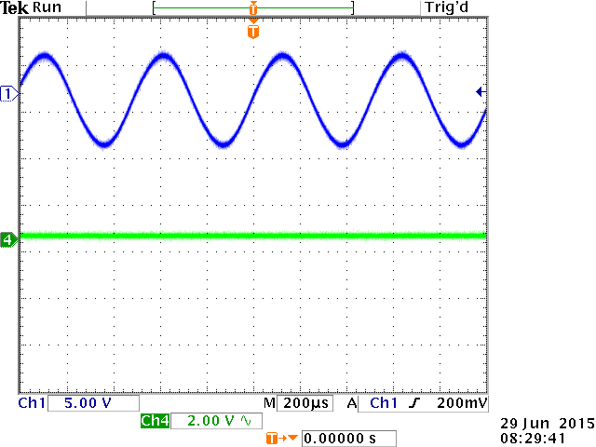

1. The number of the errors can be corrected is shown below.

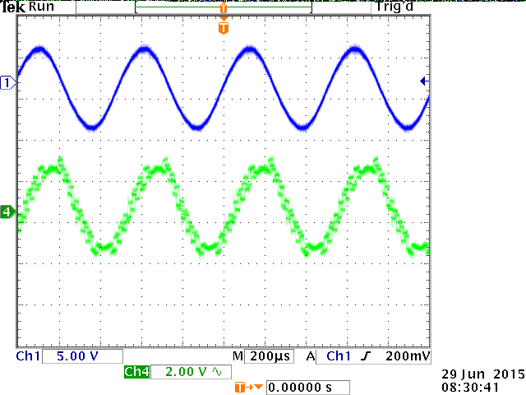

1. For one bit error the audio signal will not be clear and two bit errors sound can’t be listen.

The advanced signal generator box and generate a signal have been used.

The RF centre used frequency to 70 MHz. This is because we have a matching receiver only for 70 MHz . The bit generator was set to a pseudo noise generator with maximum length. The digital modulated data rate was set to 1 kbit/s or 10 kbit/s. The modulation set to QPSK. The modulation was set to QPSK.

Eye diagrams for the I and Q component on the scope.

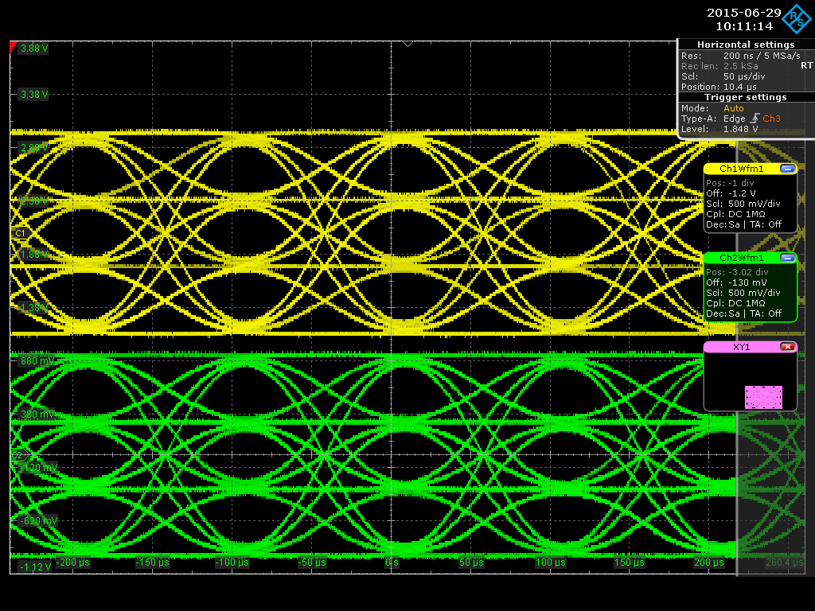

I/Q constellation on the scope by using the X/Y display feature.

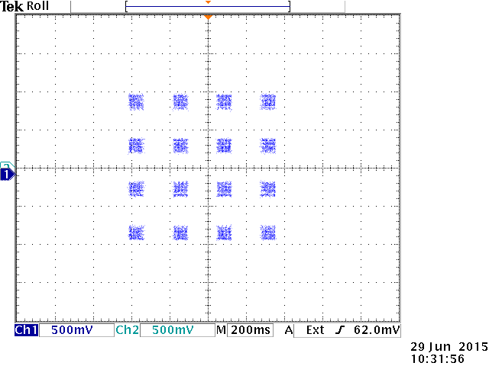

The modulation has been changed to 16QAM and repeated the last three steps

I and Q

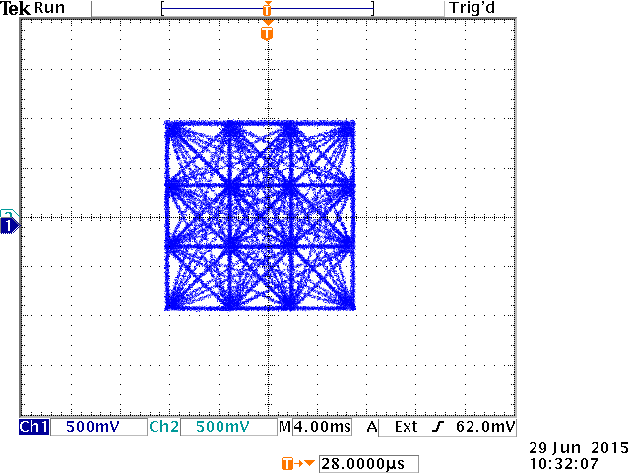

I/Q constellation on the scope by using the X/Y display feature.

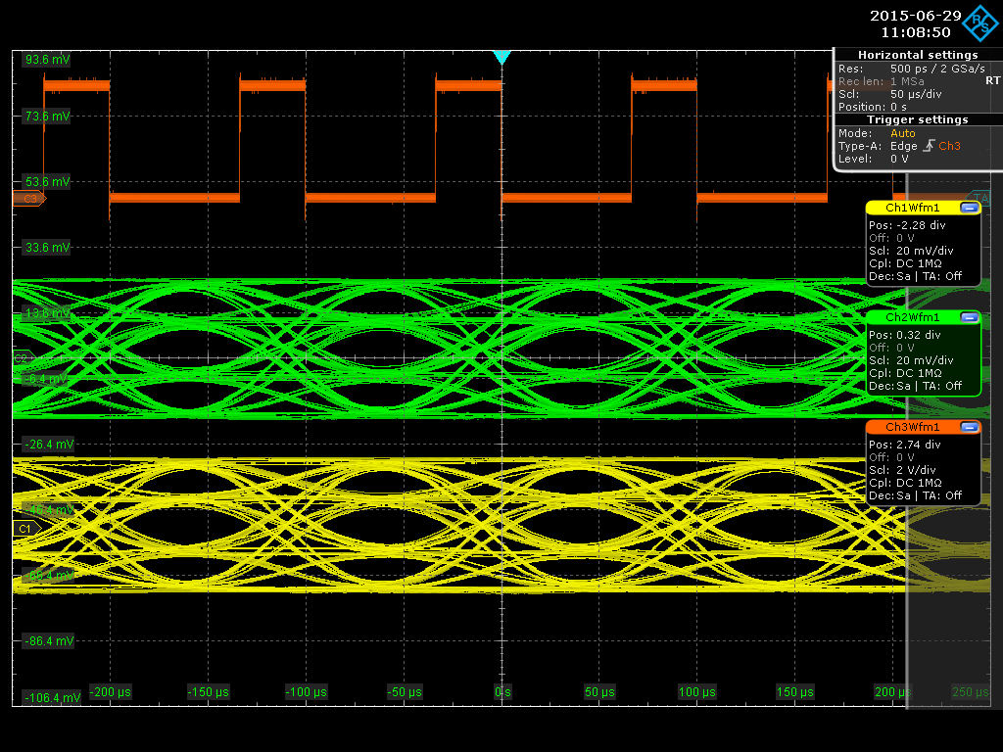

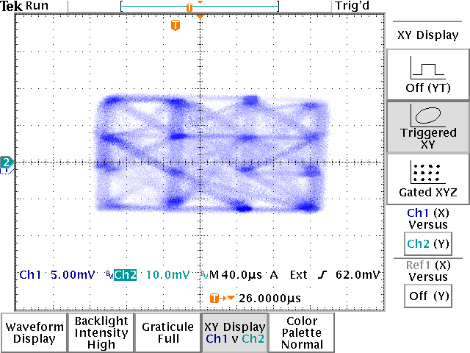

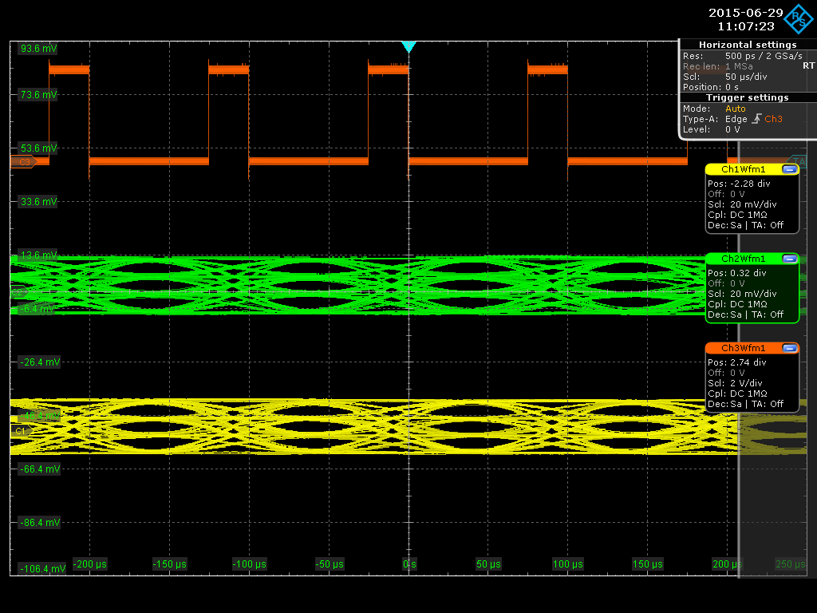

32 QAM

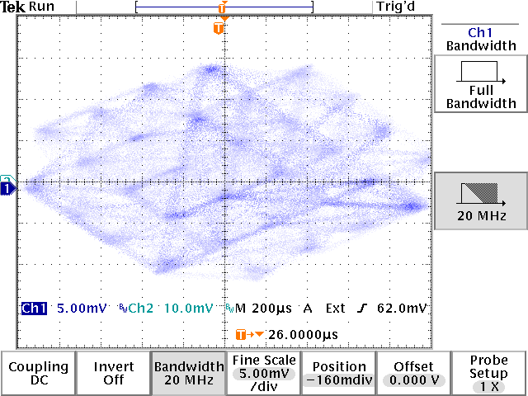

64QAM

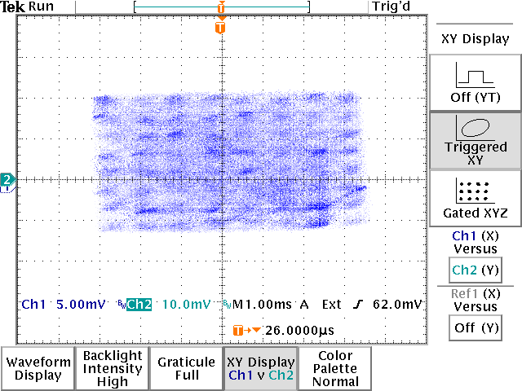

QPSK

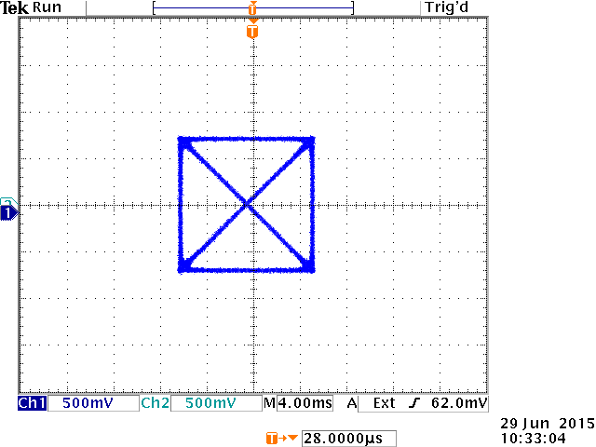

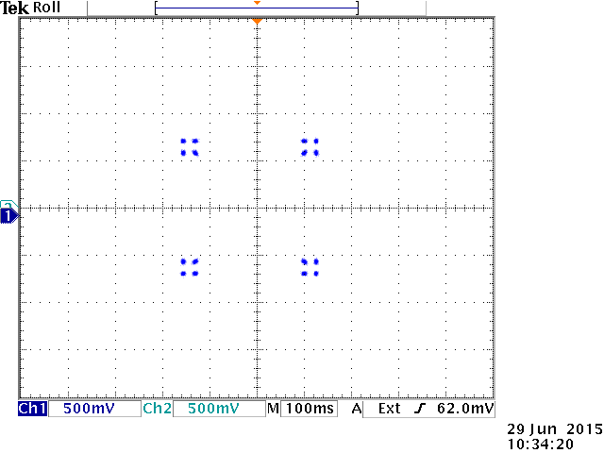

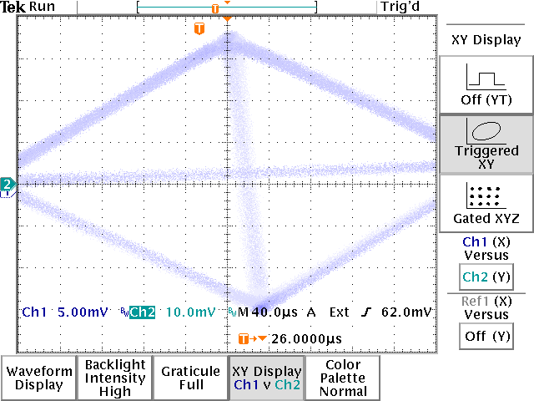

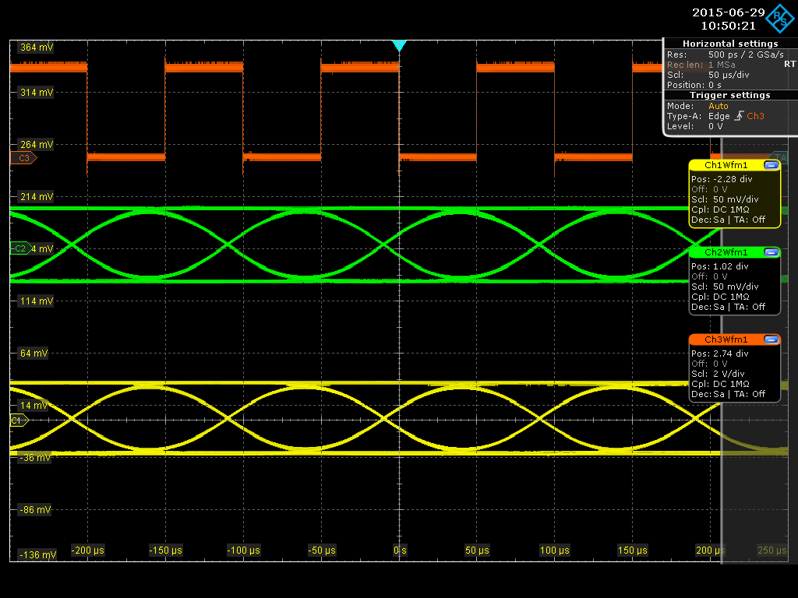

The experiment have also been done will be shown down

8psk

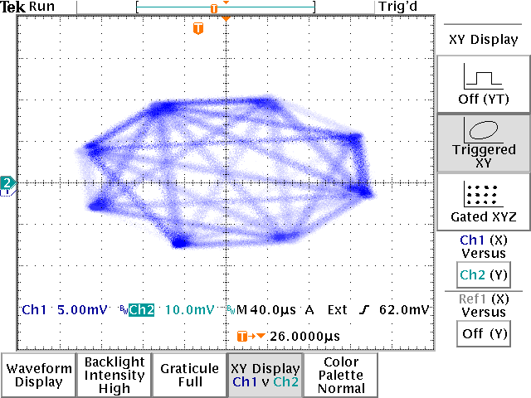

8psk at 90°

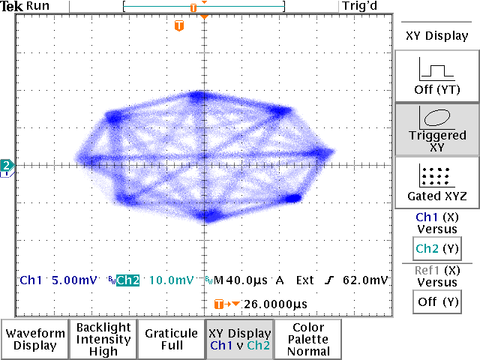

pqsk 2 points

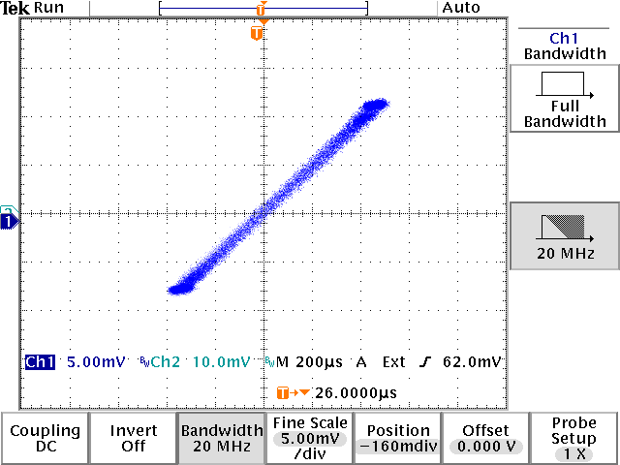

Ask

